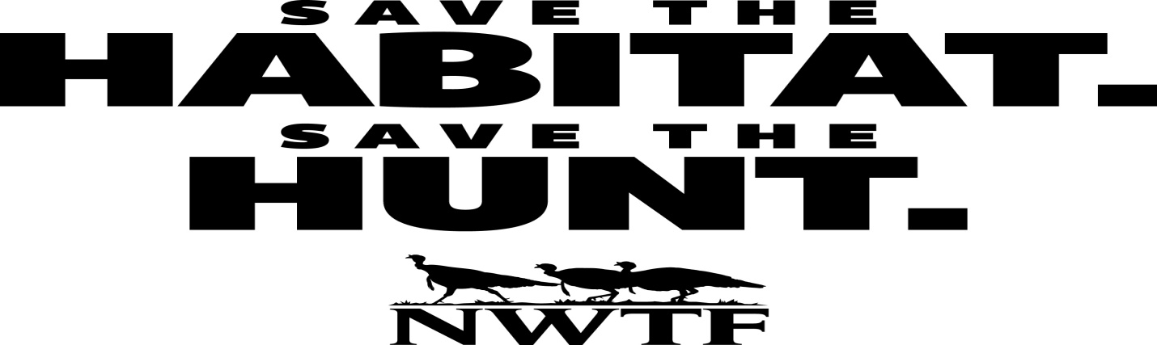

Attention Guidance Counselor:

The Northeast Nebraska Beards and Spurs Chapter of the National Wild Turkey Federation is excited to be able to offer this scholarship opportunity to your students. Please take a moment to offer this information to as many students as you can. Our goal is to reach as many students as possible for this awesome opportunity.

I am attaching a copy of the scholarship application. You can also go to the website listed below for the application as well.

Go to: https://www.nwtf.org/resource-library/detail/scholarship-application to print off the application. Forward the required information to Gina Glaser, 205 West Sycamore Avenue, Norfolk, NE 68701

Fill in our information for the local scholarship and mail it to the address listed post marked no later than January 1, 2018.

Our Local Scholarship Winner will receive a minimum of $250 to $1,000.

The winner of each local Chapters scholarship goes on to the National scholarship competion to compete for a $10,000 scholarship.

If the winner is NOT a current NWTF member we will pay for their membership and their ticket & their parents to attend our local banquet February 3, 2018.

