For more information about the

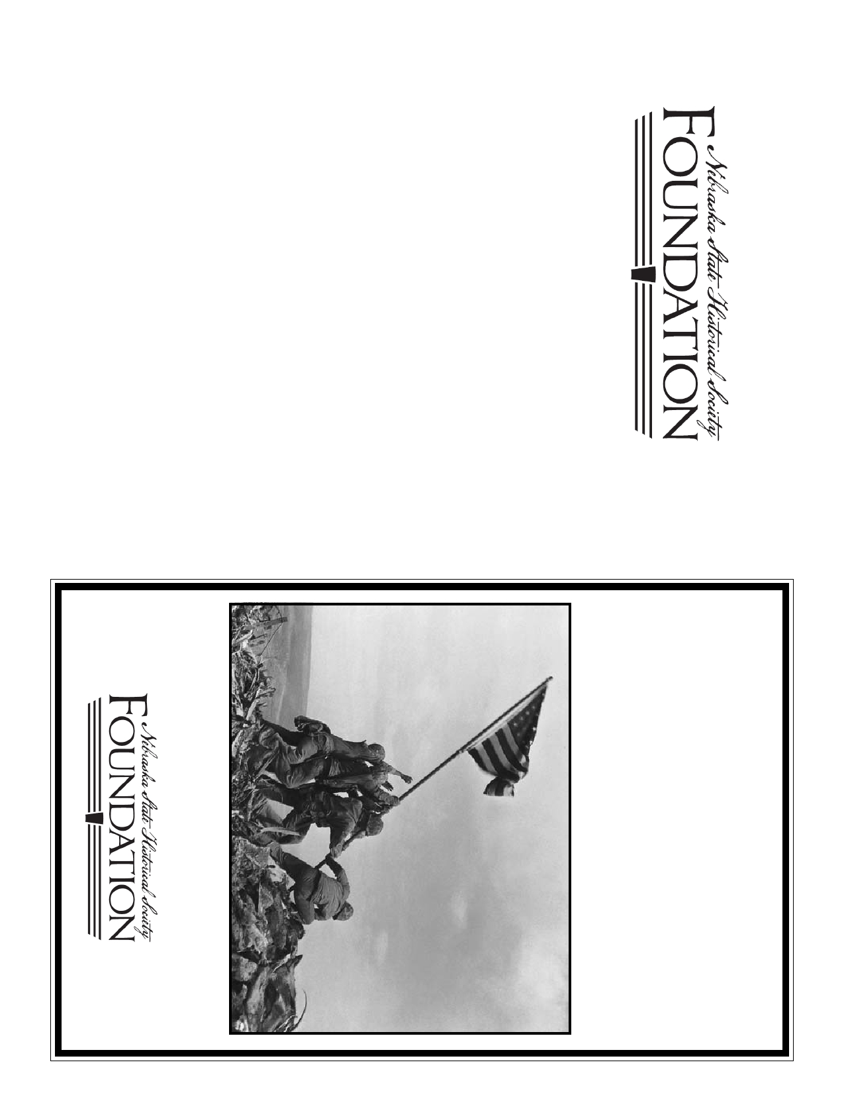

and appreciation of Nebraska History.

Mission is to support the preservation, interpretation

Nebraska State Historical Society Foundation,

**Remembrance Award Awards**

**War II Scholarship and**

**The Nebraskans of World**

**Pearl Harbor**

The Nebraska State Historical Society Foundation's

please contact:

Leslie Fattig

Executive Director

Nebraska State Historical Society Foundation

Kinman-Oldfield Suite

128 N 13th, #1010

Lincoln, NE 68508

(402) 435-3535

lfattig@nshsf.org

Administered by

The Foundation was incorporated in 1942 as a 501(c)3.

forward the nominations of no more than two seniors to be reviewed by the

below. Schools serving those communities, both public and private, may

that do not receive the Nebraskans of World War II Scholarship will be

Family members of Foundation and Society staff and/or trustees are not not

**award up to four (4) $2,000 scholarships and two (2) $600 Pearl Harbor**

**War II Scholarship**

**The Nebraskans of World**

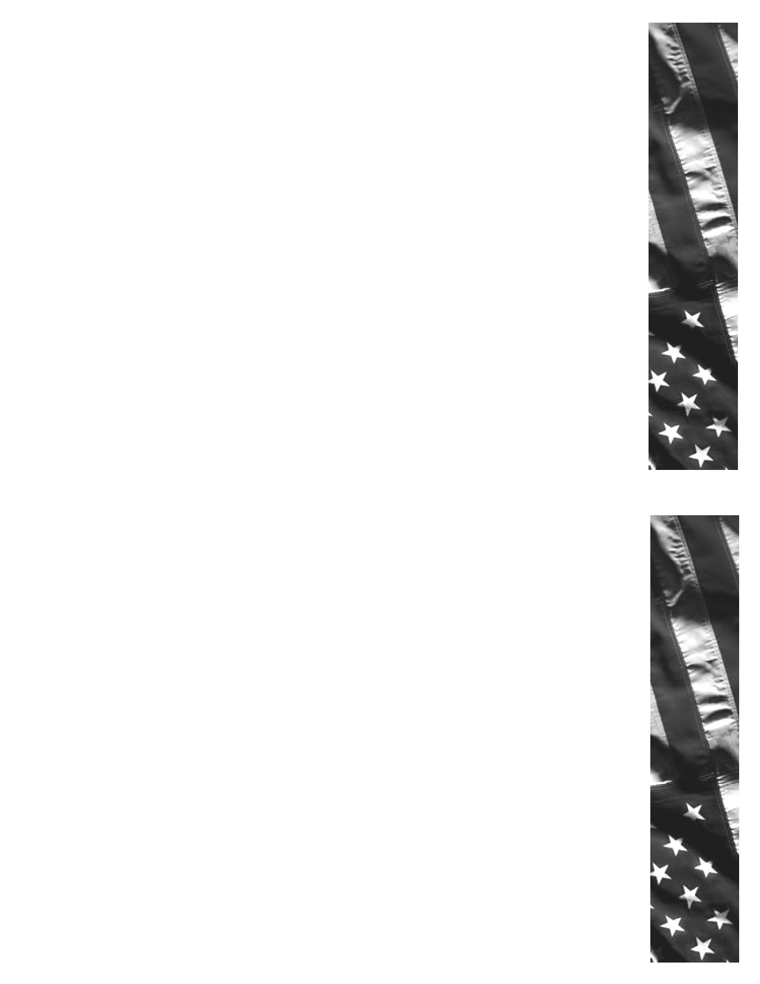

**The Scholarships**

In 2018, **The Nebraskans of World War II Scholarship Fund will**

**Remembrance Awards** to outstanding seniors from the communities listed

Scholarship Committee. The scholarship recipients will be announced no

later than April 1, 2018.

The Nebraskans of World War II Scholarship Fund was created

to memorialize the brave men and women of Nebraska who

served their country fighting for the freedoms of millions of

People.

Two Lincoln, Nebraska servicemen in particular have been

memorialized by their families through these scholarships:

Edward J. Clough and Adrian B. DePutron.

Students must complete the nomination form and provide the supporting

materials to the Scholarship Committee no later than **January 26, 2018**.

Nomination forms are available at the school counselor's office. Nominees

considered for the Pearl Harbor Remembrance Award.

GM1c Edward Clough was killed during the Japanese attack on

Pearl Harbor on December 7, 1941, and remains entombed

aboard the U.S.S. Arizona. His sister, Helen, chose to honor his

memory through a gift that would help establish the Nebraskans

of World War II Scholarship Fund.

eligible to receive scholarships.

Seniors applying must be from the school districts which encompass the

hometowns of the memorialized sailors. The hometowns are:

Lt. Adrian DePutron was killed during the Battle of the Bulge on

January 20, 1945, while serving with General Patton's Third

Army. The Lieutenant's Aunt Marjorie Barstow, through her

estate, honored her nephew's service with a gift to help enhance

the scholarship program.

Alda

Broken Bow

Brule

Central City

Cozad

Nelson

Gothenburg

Kearney

Lincoln

Madison

Mitchell

Ravenna

Newark (Minden)

North Bend

Omaha

Palisade

Potter

The Nebraskans of World War II Scholarship Fund provides up

to four (4) $2,000 scholarships to high school seniors from the

school districts which encompass the communities that were

hometowns of the entombed Nebraska sailors.

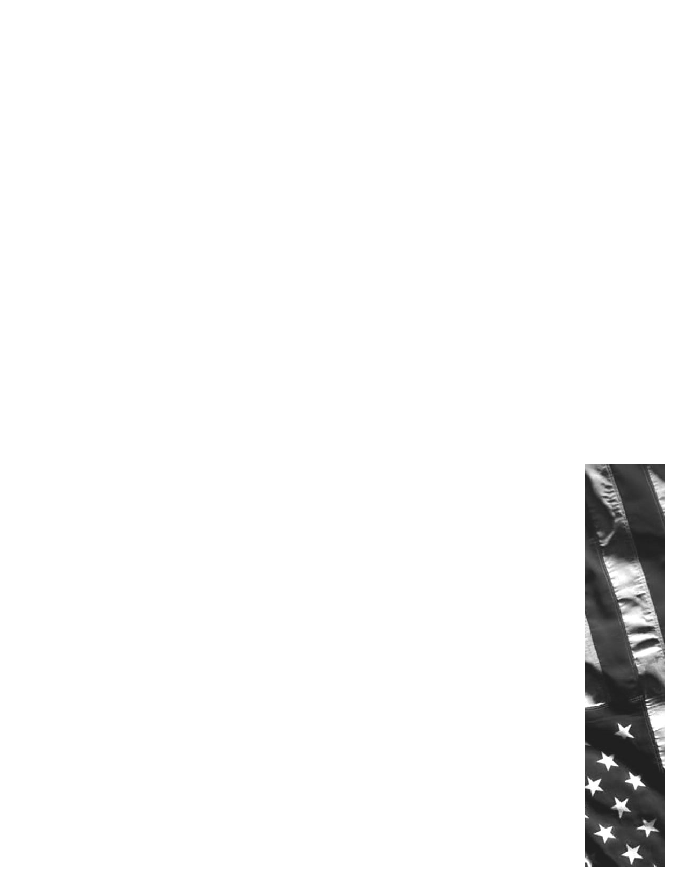

**Remembrance Award**

**The Pearl Harbor**

remain entombed in the U.S.S. Arizona.

killed during the Japanese attack on Pearl Harbor and

and his wife Vada to honor the 22 Nebraskans who were

by Colonel Barney Oldfield, a Tecumseh, Nebraska native,

The Pearl Harbor Remembrance Award fund was created

*~Colonel Oldfield*

*to awards for all of time to come."*

*Remembrance fund which links the names of those 22 men*

*for that reason we established the Pearl Harbor*

*given them by distance of both mileage and time. It was*

*deserve more than dismissal as statistics and the anonymity*

*Those who lost their lives and those who knew them*

*wanted to do more than lay a wreath or say a prayer.*

*Nebraskans who lost their lives in Pearl Harbor. We*

*"Vada and I wanted to do something to honor those*

Scholarship.

did not receive The Nebraskans of World War II

(2) *600* awards to high school seniors who applied for but

The Pearl Harbor Remembrance Fund provides up to two

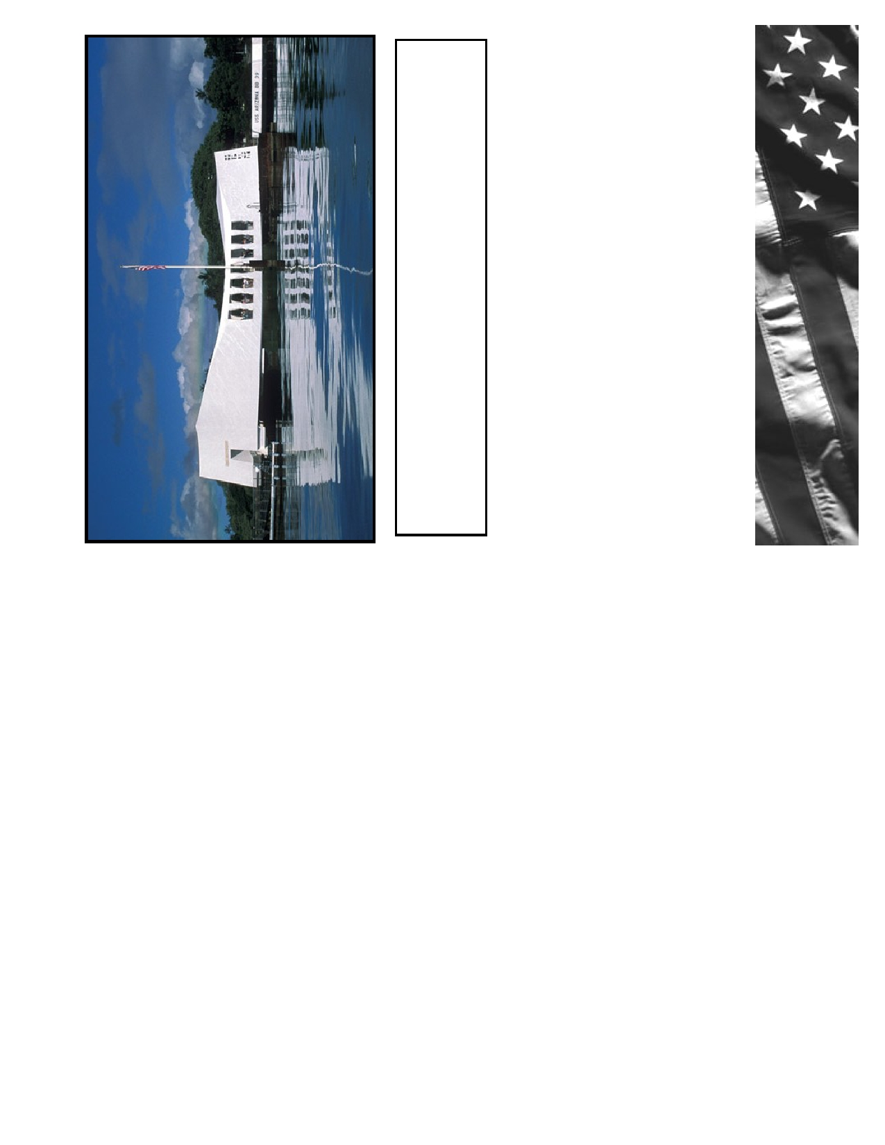

**In Memory**

with the USS Arizona are listed below.

today. This battleship became a final resting place to these men. The 22 Nebraska soldiers entombed

harbor. Of the 1,177 men killed on board USS Arizona, 1,102 men are still buried within the battleship

This memorial is built right on top of the USS Arizona battleship that still remains on the bottom of the

Pearl Harbor—USS Arizona Memorial

F1c James Thomas Hasl, Omaha

Cox Peter John Harris, Lincoln

S1c Richard Everett Ellis, Omaha

Ptrlc William R. Eernisse, North Bend

GM1c Edward Jay Clough, Lincoln

Cox Robert R. Clayton, Central City

F1c Loyd Raymond Christensen, Alda

S1c Naamen N. Chapman, Mitchell

CMM Harry L. Browne, Ravenna

F1c Kenneth Robert Bickel, Potter

HA1c Gerald Arthur Atkins, Gothenburg

MM1c Elmer Pershing Schlund, St. Michael

Capt. Thomas Leroy Kirkpatrick, Cozad

Y3c Warren Allen Jones, Kearney

HA1c Lester John Hoelscher, Madison

SC3c Stanley Kula, Omaha

SC3c Elmer Elias Yates, Palisade

RM2c Tom Savin, Omaha

S1c Gerald Harold Riggins, Brule

Mus2c Neal Jason Radford, Newark

S2c Max Valdyne Peery, Nelson

Ens Frank Stuart Lomax, Broken Bow