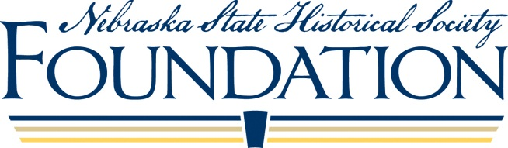

MEDIA RELEASE FORM

for the Nebraskan’s of World War II Scholarship/Pearl Harbor Award

Applicant Name____________________________________________________________________

School____________________________________________________________________

The Nebraska State Historical Society Foundation would like consent to release the student’s name, essay and jpeg photo through a press release to the media and on the NSHS Foundation web site if they receive a scholarship.

____Yes, I give my consent.

____No, I do not give my consent.

Signature of Parent/Guardian (if Student is under 18) Date

Address of Parent/Guardian (City, State Zip)

(Or)

Signature of Student (if 18 or over) Date

Address of Student (City, State Zip)

INSTRUCTIONS: Please return the completed form with your Nomination Form. If you have any questions please call the NSHS Foundation at 402-435-3535.

